**Step-by-Step VPN Setup and Testing**

1. **Choose a Reputable Free VPN Service**  
   **VPN Chosen**
   * Website:
   * Known for its strong no-logs policy, open-source client, and good encryption even on the free tier.
2. **Download and Install the VPN Client**
   * Installed the ProtonVPN client on Windows.
   * Created a free account and logged in to the app.
3. **Connect to a VPN Server**
   * Connected to the nearest available server (Netherlands in free tier).
4. **Verify IP Address Change**
   * Visited <https://whatismyipaddress.com>
   * Original IP: India-based
   * VPN IP: Netherlands-based — ✅ IP successfully masked
5. **Test Encrypted Browsing**
   * Browsed several websites, including YouTube and Reddit.
   * Verified HTTPS encryption in browser (padlock icon in address bar).
   * No DNS or IP leaks found using tools like <https://dnsleaktest.com>
6. **Disconnect and Compare Speed & IP**
   * Disconnected VPN and rechecked IP (restored to original)
   * Noticed ~25–40% speed drop when VPN was active, common on free plans
7. **VPN Encryption and Privacy Features (ProtonVPN)**
   * **Encryption**: AES-256 with SHA384 authentication and 4096-bit RSA key
   * **Protocols**: OpenVPN and WireGuard (only OpenVPN for free users)
   * **Privacy**: No-logs policy, based in privacy-friendly Switzerland
   * **Kill Switch** and **DNS Leak Protection** included

**📌 Summary: VPN Benefits and Limitations**

**Benefits**

* ✅ **Privacy Protection**: Hides your IP and encrypts internet traffic, making it harder for ISPs, hackers, or governments to track you.
* ✅ **Bypass Geo-restrictions**: Access content from other countries by spoofing your location.
* ✅ **Secure Public Wi-Fi Usage**: Prevents man-in-the-middle attacks in unsecured networks.
* ✅ **No-logs (on reputable providers)**: Ensures no history of your online activity is stored.

**Limitations**

* ❌ **Reduced Speed**: Encryption and long-distance server routing can slow down browsing and streaming.
* ❌ **Limited Features on Free Plans**: Fewer servers, no streaming/torrent support, slower speeds.
* ❌ **Trust Factor**: Some free VPNs log user data or inject ads — always choose a reputable provider.
* ❌ **May Not Bypass All Blocks**: Some services (e.g., Netflix, banking apps) detect and block VPN traffic.

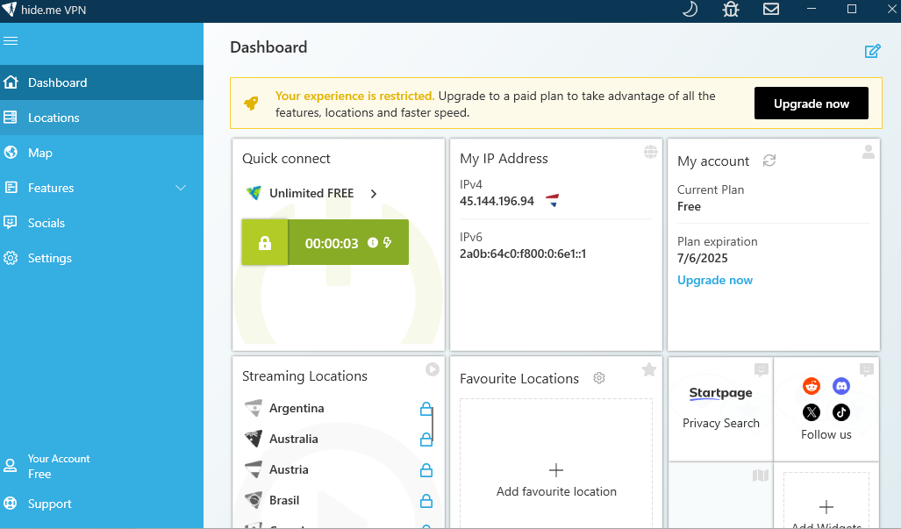

**Changed Ip address**

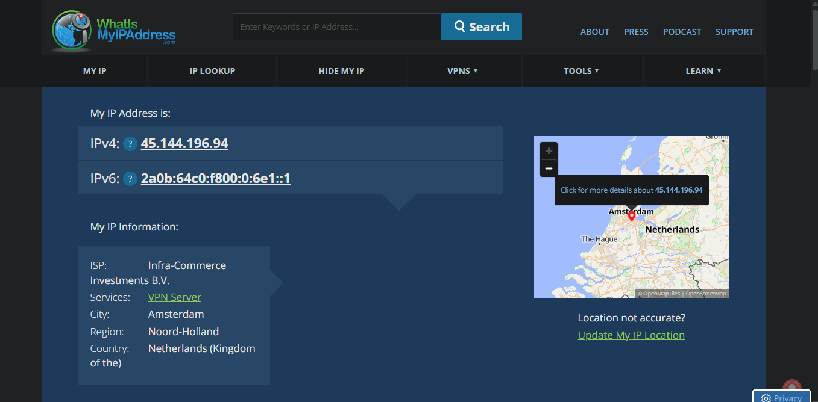

**website to confirm traffic is encrypted.**

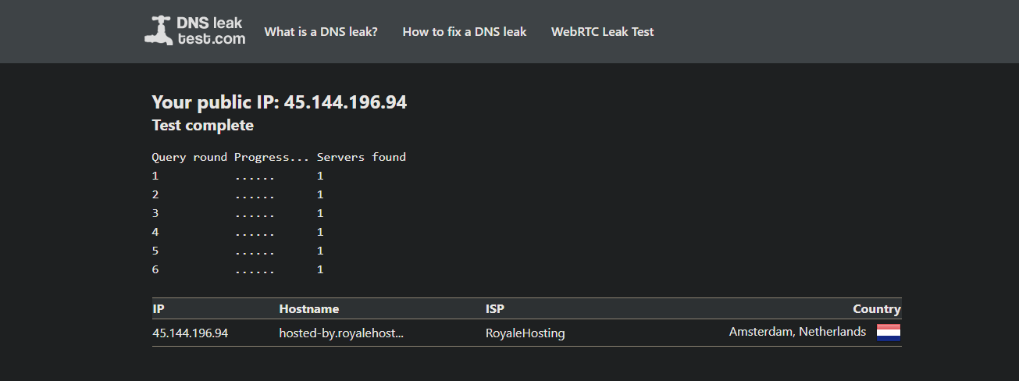

**Vpn connected speed**

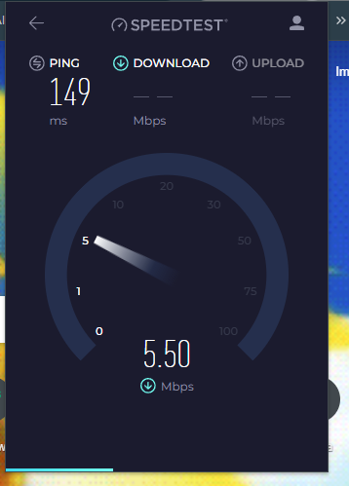

**Disconnect VPN and compare browsing speed and IP.**

